Assignment

GroupD

1/21/2020

# 

# SERIE 1

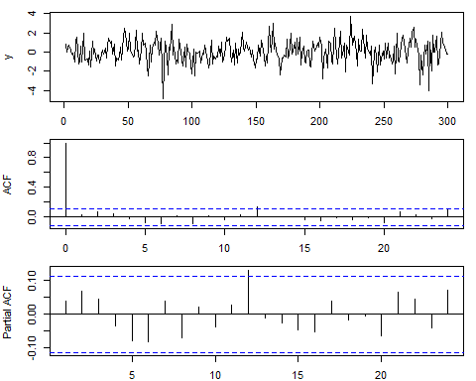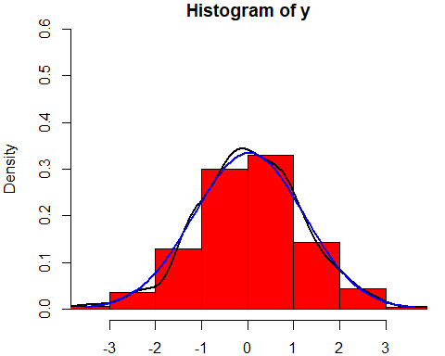

## Tests Serie 1

### Mean:

## [1] 0.03205

### St Deviation:

## [1] 1.193712

### Skewness:

## [1] -0.2795834  
## attr(,"method")  
## [1] "moment"

### Kurtosis:

## [1] 4.040454  
## attr(,"method")  
## [1] "moment"

### Dickey Fuller:

## [1] 0

### Shapiro Test:

##   
## Shapiro-Wilk normality test  
##   
## data: y  
## W = 0.98868, p-value = 0.01941

### Box test (Linear correlation):

##   
## Box-Ljung test  
##   
## data: y  
## X-squared = 18.804, df = 20, p-value = 0.5346

## Analysis of the squared data

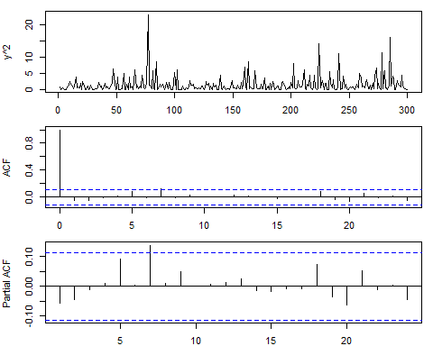

### Box test (Squared correlation):

##   
## Box-Ljung test  
##   
## data: y^2  
## X-squared = 14.168, df = 20, p-value = 0.8219

# SERIE 2

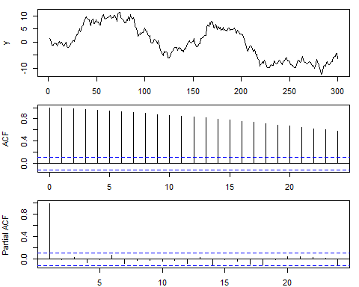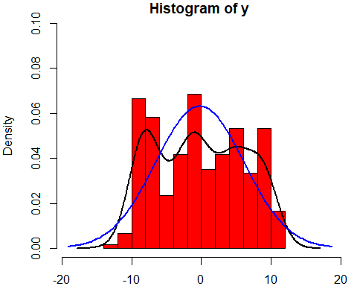

## Tests Serie 2

### Mean:

## [1] -0.22853

### St Deviation:

## [1] 6.31268

### Skewness:

## [1] 0.04883792  
## attr(,"method")  
## [1] "moment"

### Kurtosis:

## [1] 1.765163  
## attr(,"method")  
## [1] "moment"

### Dickey Fuller:

## [1] 1

### Shapiro Test:

##   
## Shapiro-Wilk normality test  
##   
## data: y  
## W = 0.94921, p-value = 1.133e-08

### Box test (Linear correlation):

##   
## Box-Ljung test  
##   
## data: y  
## X-squared = 4509.5, df = 20, p-value < 2.2e-16

## Analysis of the squared data

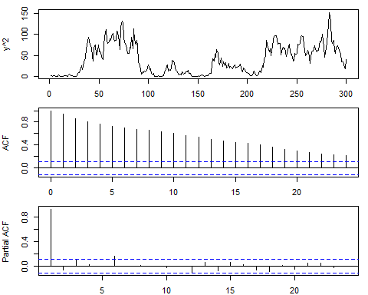

### Box test (Squared correlation):

##   
## Box-Ljung test  
##   
## data: y^2  
## X-squared = 2317.4, df = 20, p-value < 2.2e-16

# SERIE 2 DIFF

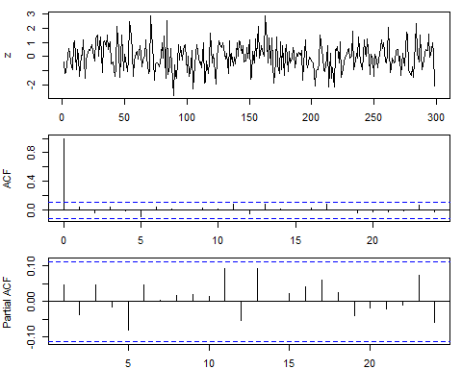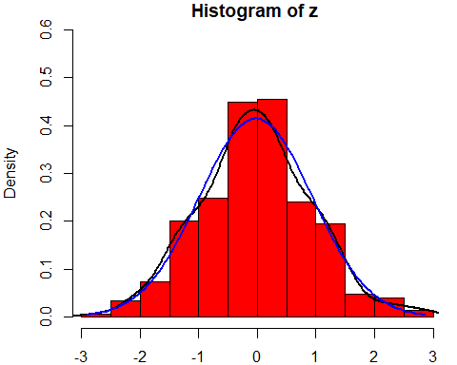

## Tests Serie 2 Diff

### Mean:

## [1] -0.02598662

### St Deviation:

## [1] 0.9620915

### Skewness:

## [1] 0.1359436  
## attr(,"method")  
## [1] "moment"

### Kurtosis:

## [1] 3.096639  
## attr(,"method")  
## [1] "moment"

### Dickey Fuller:

## [1] 0

### Shapiro Test:

##   
## Shapiro-Wilk normality test  
##   
## data: z  
## W = 0.99619, p-value = 0.69

### Box test (Linear correlation):

##   
## Box-Ljung test  
##   
## data: z  
## X-squared = 12.452, df = 20, p-value = 0.8996

## Analysis of the squared data

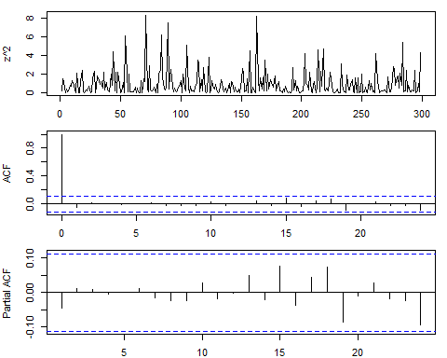

### Box test (Squared correlation):

##   
## Box-Ljung test  
##   
## data: z^2  
## X-squared = 9.7899, df = 20, p-value = 0.9718

# SERIE 3

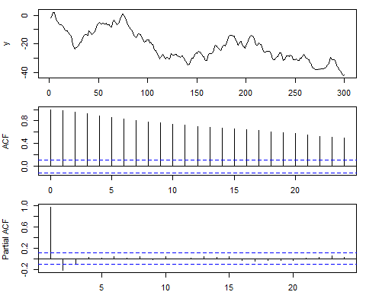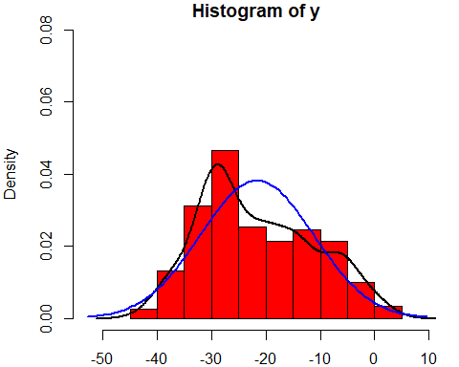

## Tests Serie 3

### Mean:

## [1] -21.65212

### St Deviation:

## [1] 10.42905

### Skewness:

## [1] 0.3495993  
## attr(,"method")  
## [1] "moment"

### Kurtosis:

## [1] 2.197106  
## attr(,"method")  
## [1] "moment"

### Dickey Fuller:

## [1] 1

### Shapiro Test:

##   
## Shapiro-Wilk normality test  
##   
## data: y  
## W = 0.9645, p-value = 1.019e-06

### Box test (Linear correlation):

##   
## Box-Ljung test  
##   
## data: y  
## X-squared = 3598.9, df = 20, p-value < 2.2e-16

## Analysis of the squared data

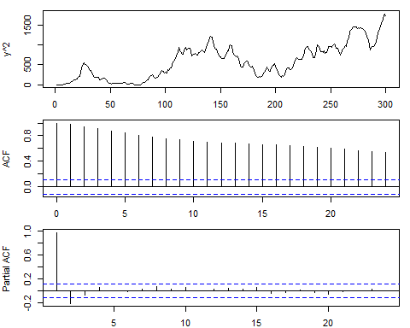

### Box test (Squared correlation):

##   
## Box-Ljung test  
##   
## data: y^2  
## X-squared = 3552, df = 20, p-value < 2.2e-16

# SERIE 3 DIFF

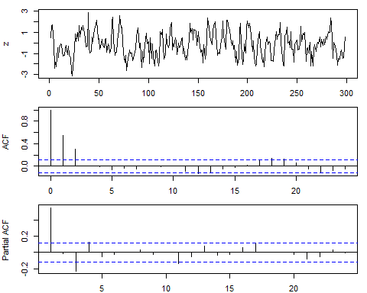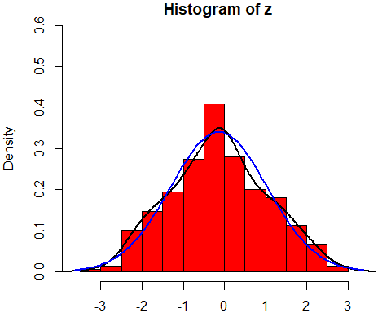

## Tests Serie 3 Diff

### Mean:

## [1] -0.1338495

### St Deviation:

## [1] 1.172368

### Skewness:

## [1] 0.06834054  
## attr(,"method")  
## [1] "moment"

### Kurtosis:

## [1] 2.523204  
## attr(,"method")  
## [1] "moment"

### Dickey Fuller:

## [1] 0

### Shapiro Test:

##   
## Shapiro-Wilk normality test  
##   
## data: z  
## W = 0.99344, p-value = 0.2178

### Box test (Linear correlation):

##   
## Box-Ljung test  
##   
## data: z  
## X-squared = 148.71, df = 20, p-value < 2.2e-16

## Analysis of the squared data

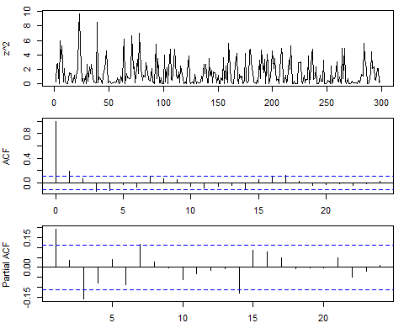

### Box test (Squared correlation):

##   
## Box-Ljung test  
##   
## data: z^2  
## X-squared = 47.582, df = 20, p-value = 0.0004868

# SERIE 4

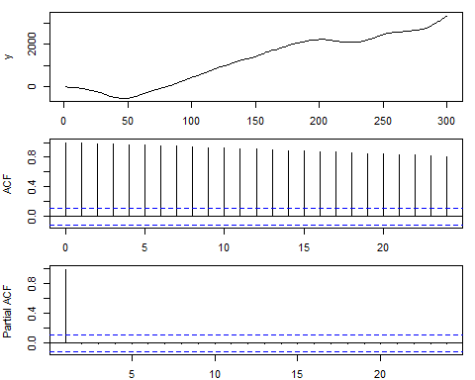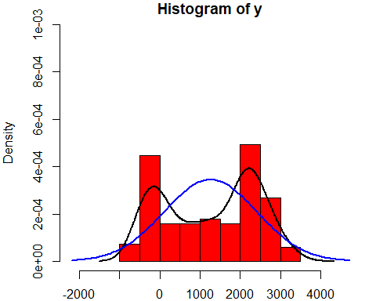

## Tests Serie 4

### Mean:

## [1] 1256.843

### St Deviation:

## [1] 1154.857

### Skewness:

## [1] -0.1488262  
## attr(,"method")  
## [1] "moment"

### Kurtosis:

## [1] 1.559977  
## attr(,"method")  
## [1] "moment"

### Dickey Fuller:

## [1] 2

### Shapiro Test:

##   
## Shapiro-Wilk normality test  
##   
## data: y  
## W = 0.91161, p-value = 2.779e-12

### Box test (Linear correlation):

##   
## Box-Ljung test  
##   
## data: y  
## X-squared = 5290.9, df = 20, p-value < 2.2e-16

## Analysis of the squared data

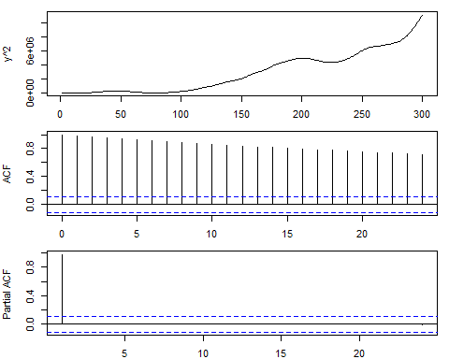

### Box test (Squared correlation):

##   
## Box-Ljung test  
##   
## data: y^2  
## X-squared = 4641.8, df = 20, p-value < 2.2e-16

# SERIE 4 DIFF

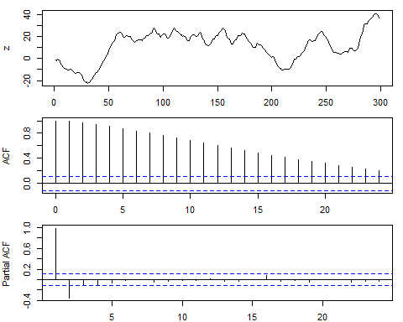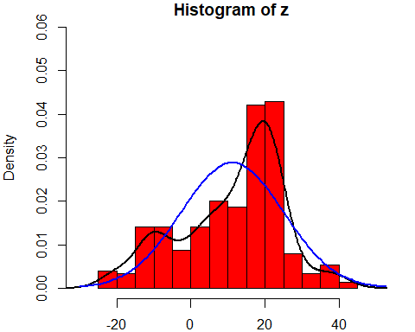

## Tests Serie 4 Diff

### Mean:

## [1] 11.17006

### St Deviation:

## [1] 13.82722

### Skewness:

## [1] -0.5206655  
## attr(,"method")  
## [1] "moment"

### Kurtosis:

## [1] 2.625407  
## attr(,"method")  
## [1] "moment"

### Dickey Fuller:

## [1] 1

### Shapiro Test:

##   
## Shapiro-Wilk normality test  
##   
## data: z  
## W = 0.94851, p-value = 9.871e-09

### Box test (Linear correlation):

##   
## Box-Ljung test  
##   
## data: z  
## X-squared = 2974.9, df = 20, p-value < 2.2e-16

## Analysis of the squared data

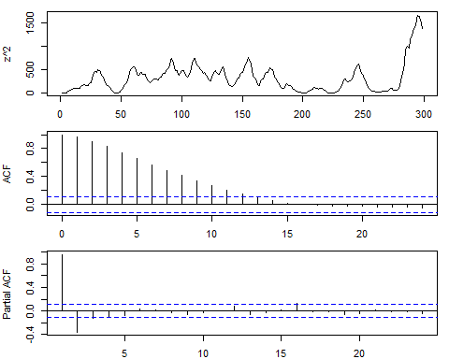

### Box test (Squared correlation):

##   
## Box-Ljung test  
##   
## data: z^2  
## X-squared = 1354.2, df = 20, p-value < 2.2e-16

# SERIE 4 2DIFF

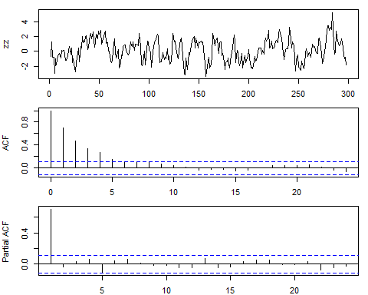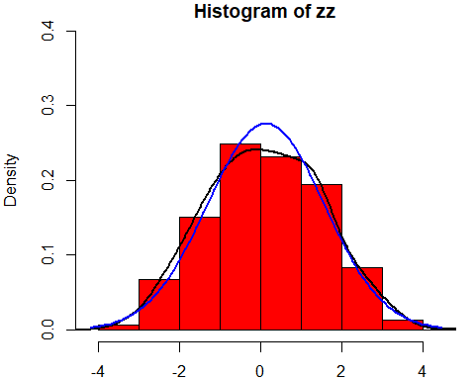

## Tests Serie 4 2Diff

### Mean:

## [1] 0.1287819

### St Deviation:

## [1] 1.445643

### Skewness:

## [1] 0.1289298  
## attr(,"method")  
## [1] "moment"

### Kurtosis:

## [1] 2.761813  
## attr(,"method")  
## [1] "moment"

### Dickey Fuller:

## [1] 0

### Shapiro Test:

##   
## Shapiro-Wilk normality test  
##   
## data: zz  
## W = 0.99438, p-value = 0.3416

### Box test (Linear correlation):

##   
## Box-Ljung test  
##   
## data: zz  
## X-squared = 297.76, df = 20, p-value < 2.2e-16

## Analysis of the squared data

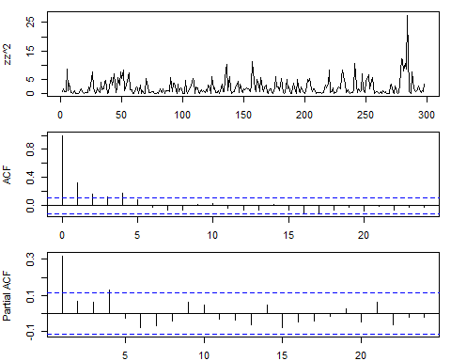

### Box test (Squared correlation):

##   
## Box-Ljung test  
##   
## data: zz^2  
## X-squared = 72.7, df = 20, p-value = 6.562e-08

# SERIE 5

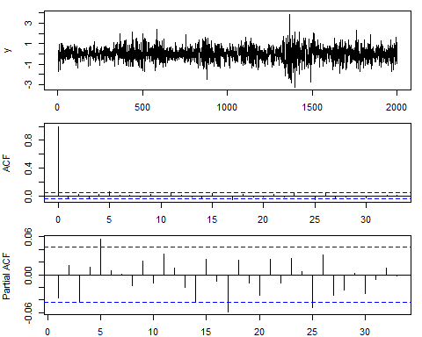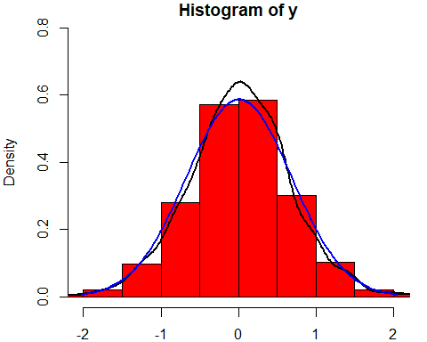

## Tests Serie 5

### Mean:

## [1] 0.0071755

### St Deviation:

## [1] 0.6797896

### Skewness:

## [1] -0.08744834  
## attr(,"method")  
## [1] "moment"

### Kurtosis:

## [1] 4.36924  
## attr(,"method")  
## [1] "moment"

### Dickey Fuller:

## [1] 0

### Shapiro Test:

##   
## Shapiro-Wilk normality test  
##   
## data: y  
## W = 0.99047, p-value = 3.456e-10

### Box test (Linear correlation)Lag=20:

##   
## Box-Ljung test  
##   
## data: y  
## X-squared = 33.151, df = 20, p-value = 0.03248

### Box test (Linear correlation) Lag=10:

##   
## Box-Ljung test  
##   
## data: y  
## X-squared = 15.852, df = 10, p-value = 0.1039

## Analysis of the squared data

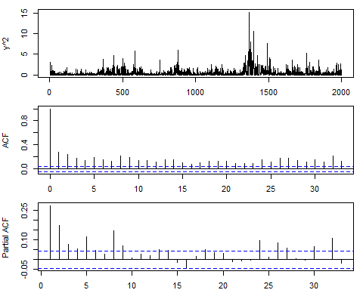

### Box test (Squared correlation):

##   
## Box-Ljung test  
##   
## data: y^2  
## X-squared = 1061.5, df = 20, p-value < 2.2e-16

# SERIE 6

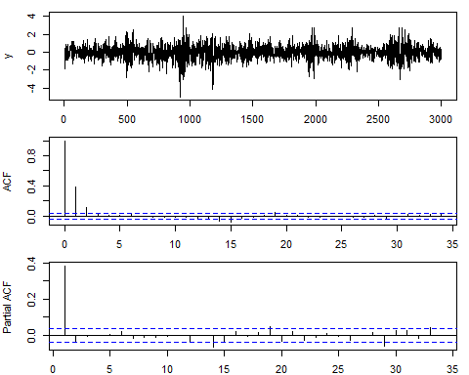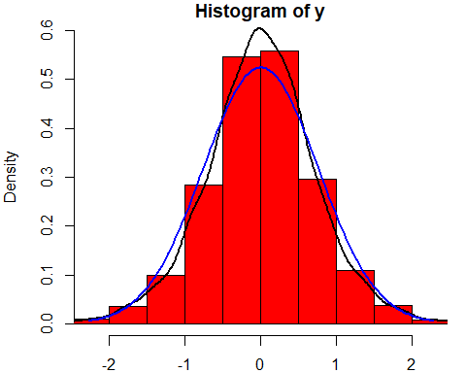

## Tests Serie 6

### Mean:

## [1] 0.007541

### St Deviation:

## [1] 0.7605913

### Skewness:

## [1] -0.2023789  
## attr(,"method")  
## [1] "moment"

### Kurtosis:

## [1] 5.113352  
## attr(,"method")  
## [1] "moment"

### Dickey Fuller:

## [1] 0

### Shapiro Test:

##   
## Shapiro-Wilk normality test  
##   
## data: y  
## W = 0.98338, p-value < 2.2e-16

### Box test (Linear correlation):

##   
## Box-Ljung test  
##   
## data: y  
## X-squared = 537.69, df = 20, p-value < 2.2e-16

## Analysis of the squared data

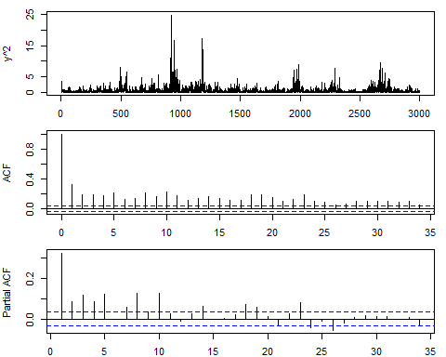

### Box test (Squared correlation):

##   
## Box-Ljung test  
##   
## data: y^2  
## X-squared = 1856.6, df = 20, p-value < 2.2e-16

# SERIE 7

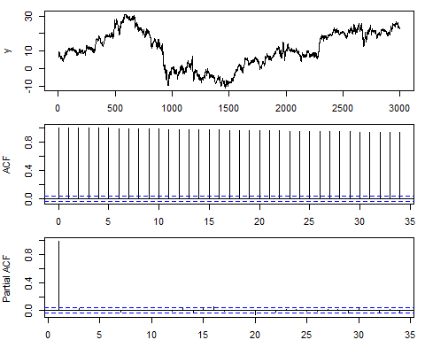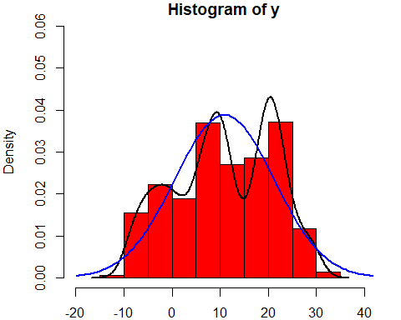

## Tests Serie 7

### Mean:

## [1] 10.88196

### St Deviation:

## [1] 10.28588

### Skewness:

## [1] -0.1702387  
## attr(,"method")  
## [1] "moment"

### Kurtosis:

## [1] 2.00975  
## attr(,"method")  
## [1] "moment"

### Dickey Fuller:

## [1] 1

### Shapiro Test:

##   
## Shapiro-Wilk normality test  
##   
## data: y  
## W = 0.96711, p-value < 2.2e-16

### Box test (Linear correlation):

##   
## Box-Ljung test  
##   
## data: y  
## X-squared = 57372, df = 20, p-value < 2.2e-16

## Analysis of the squared data

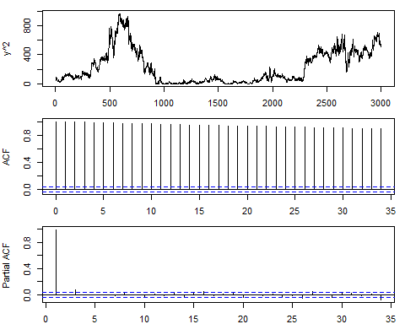

### Box test (Squared correlation):

##   
## Box-Ljung test  
##   
## data: y^2  
## X-squared = 55788, df = 20, p-value < 2.2e-16

# SERIE 7 DIFF

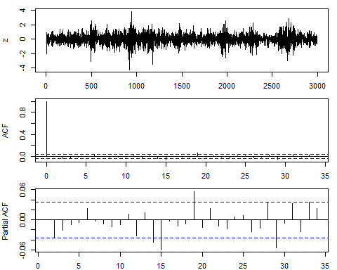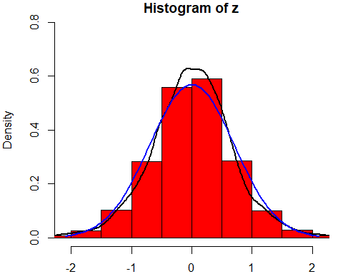

## Tests Serie 7 Diff

### Mean:

## [1] 0.004649883

### St Deviation:

## [1] 0.7023493

### Skewness:

## [1] -0.1525146  
## attr(,"method")  
## [1] "moment"

### Kurtosis:

## [1] 4.823746  
## attr(,"method")  
## [1] "moment"

### Dickey Fuller:

## [1] 0

### Shapiro Test:

##   
## Shapiro-Wilk normality test  
##   
## data: z  
## W = 0.98584, p-value < 2.2e-16

### Box test (Linear correlation) Lag=20:

##   
## Box-Ljung test  
##   
## data: z  
## X-squared = 40.012, df = 20, p-value = 0.004978

### Box test (Linear correlation) Lag =10:

##   
## Box-Ljung test  
##   
## data: z  
## X-squared = 8.2319, df = 10, p-value = 0.6062

## Analysis of the squared data

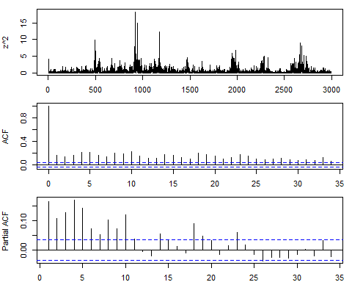

### Box test (Squared correlation):

##   
## Box-Ljung test  
##   
## data: z^2  
## X-squared = 1632.1, df = 20, p-value < 2.2e-16